**Robust adaptation strategies to non-stationarity of in-land floods under uncertainty: Elevating local houses to an optimal elevation**

Mahkameh Zarekarizi1, and Klaus Keller1,2

1 Earth and Environmental Systems Institute, Pennsylvania State University, University Park, PA

2 Department of Geosciences, Pennsylvania State University, University Park, PA

Projected Journal:

* Journal of hydrology (3.72; 2017),
* sustainability (2.075; 2017),
* Risk Analysis (2.89; 2018)
* Journal of flood risk management (2.483)
* **Journal of water resources planning and management (3.57; 2016)**

Highlights:

* Uncertainties influence the homeowner’s decision of raising the house
* FEMA’s recommendation is not always optimal
* House characteristics such as lifespan, house size, value and ground elevation are important in the optimal decision

Message Box:

* Issue:
* **Problem**: People are raising their house. Raising a house is extremely expensive. Some people abandon their houses due to frequent expensive floods.
* FEMA doesn’t specify how much people should raise their houses.
* So what:
* Solution:
* Benefits:

# Abstract

Non-stationarity of floods has been studied frequently and it has been shown that extreme floods are not necessarily time-invariant. Non-stationarity of extreme floods are generally attributed to human-induced climate change, human intervention, and/or climate variability. In order for local communities to become more resilient to future extreme floods, FEMA recommends elevating houses to one foot above the Base Flood Elevation (BFE). Since this strategy ignores the vulnerability of houses, a recent study suggested an Optimal Elevation Level (OEL) which is an economically optimal elevation based on a cost-benefit analysis. The current study complements that research by taking the uncertainties associated with such a decision into account. We discuss that variables involved in this decision are deeply uncertain. We discuss a range of strategies under different states of the world and study the robustness of various strategies. The results of this study could guide FEMA's future recommendations and the open source package provided along this paper could be used by homeowners as a tool for making a robust decision.

# Introduction

According to FEMA, Special Flood Hazard Area is referred to an area of land that is covered by the 100-yr floodway (also known as base flood elevation).

FEMA defines the base flood elevation as the elevation to which the water is expected to rise during a base flood.

FIRMS or Flood Insurance Rate Maps show BFE

The relationship between the BFE and the structure elevation indicates premium rates and says if a structure is floodproofed.

Robust decision making is essential given the uncertainties associated with climate change.

<Discussion on Robust Decision Making>

...

Robust decision making is defined as …

<Definition of Robust Decision Making>

...

Not only the stakeholders need to make such decisions but also regular people need to make such decisions.

<Discussion that RDM is not just for stakeholders>

These decisions range from simple questions such as carrying an umbrella or not to more difficult ones such as elevating a house or not.

...

Why would someone want to elevate their house?

<Discussion specifically on house elevation decision>

<introduction about the NFIP program>

<discussion about insurance premiums

...

Recently Xiang et al (2017) addressed the question of optimal house elevation but they did not discuss the robustness of such decision.

<Discussion on what could be improved in that paper>

...

But why do we need to consider non-stationarity, robust decision making, and uncertainty quantification?

<description on non-stationarity and uncertainty quantification>

This paper aims at providing a robust framework to facilitate making this decision using Robust decision support frameworks.

...

What decision support framework we would like to use and why?

...

Therefore, the objectives of this study are the following:

1. Show the results of a simple cost-benefit analysis

2. Discuss the robustness of the optimal elevation resulted from the cost-benefit analysis

3. Assess the sensitivity of the optimal elevation to the uncertatin factors.

<list the objectives>

...

<Discuss the significance and the implications of the study>

<why is it important to answer these questions>

<what are the implications of this study?>

The paper is organized as the following ...

<Organization of the paper>

# Study area

We use USGS gage

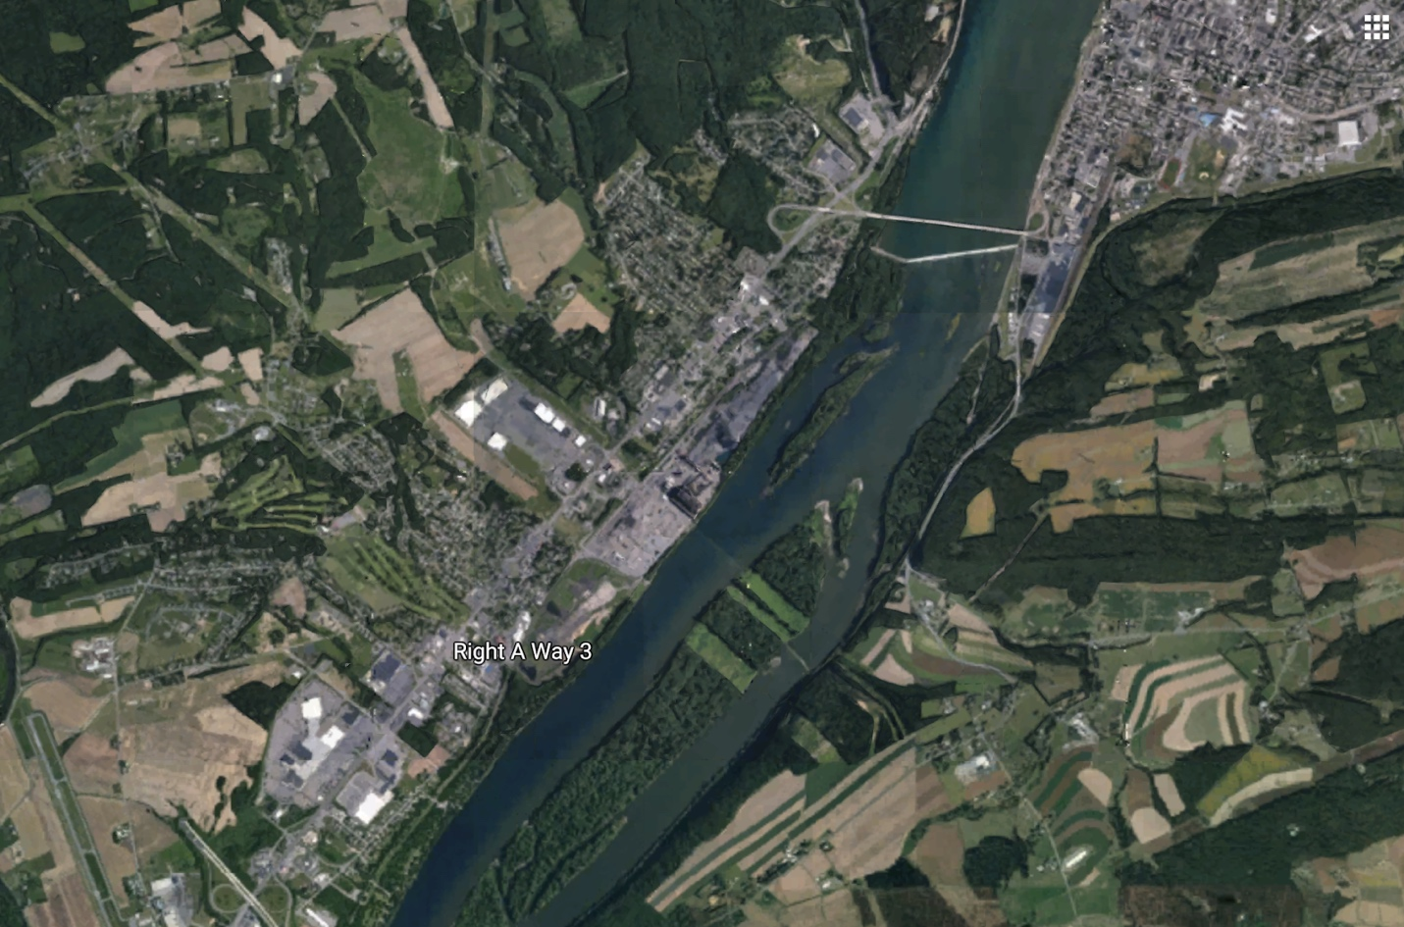

The gage numbers.

A map of the study area

Figure 1: Location of the study area

# Data

3.1 Water level data

The closest USGS gage to the community of Selinsgrove is USGS gage 01554000 collecting water data at Susquehanna River at Sunbury, Pennsylvania. The latitude and longitude of the gage are 40 50 04 and 76 49 37 and the drainage area is 18,300 square miles and the gage datum is at 408.61 feet above NGVD29. Daily discharge data at this location are available for the period of 1937 to 2019 but daily gage height data are limited to 2000-2019. Therefore, in order to take advantage of the rather long record of discharge data, the stage-discharge rating curve for this location was used to convert discharge to gage height. Gage height data estimated from the rating curve for the period of 1937 to 2019 are shown in Figure 2.

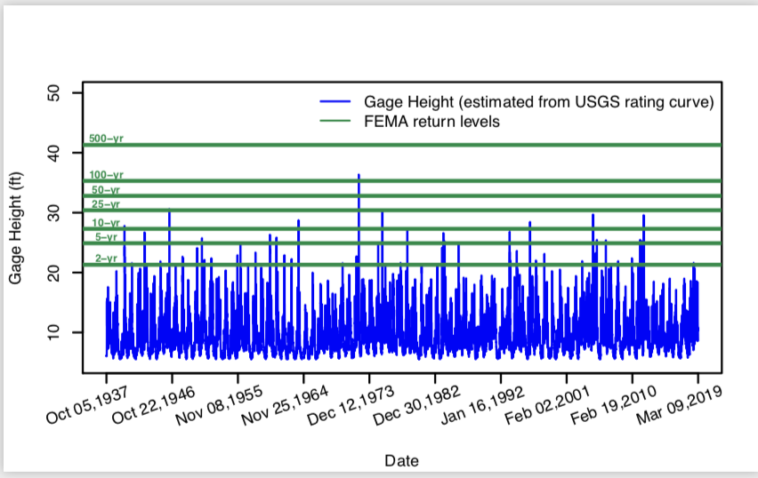

Figure 2: Estimated daily gage height data for USGS gage 01554000; Susquehanna River at Sunbury, Pennsylvania. Blue lines indicate 2, 5, 10, 25, 50, 100, and 500 return levels as determined by FEMA.

3.2 Cost of elevating the house

In this study, the costs of elevating a house are adopted from the CLARA model as shown in table 1.

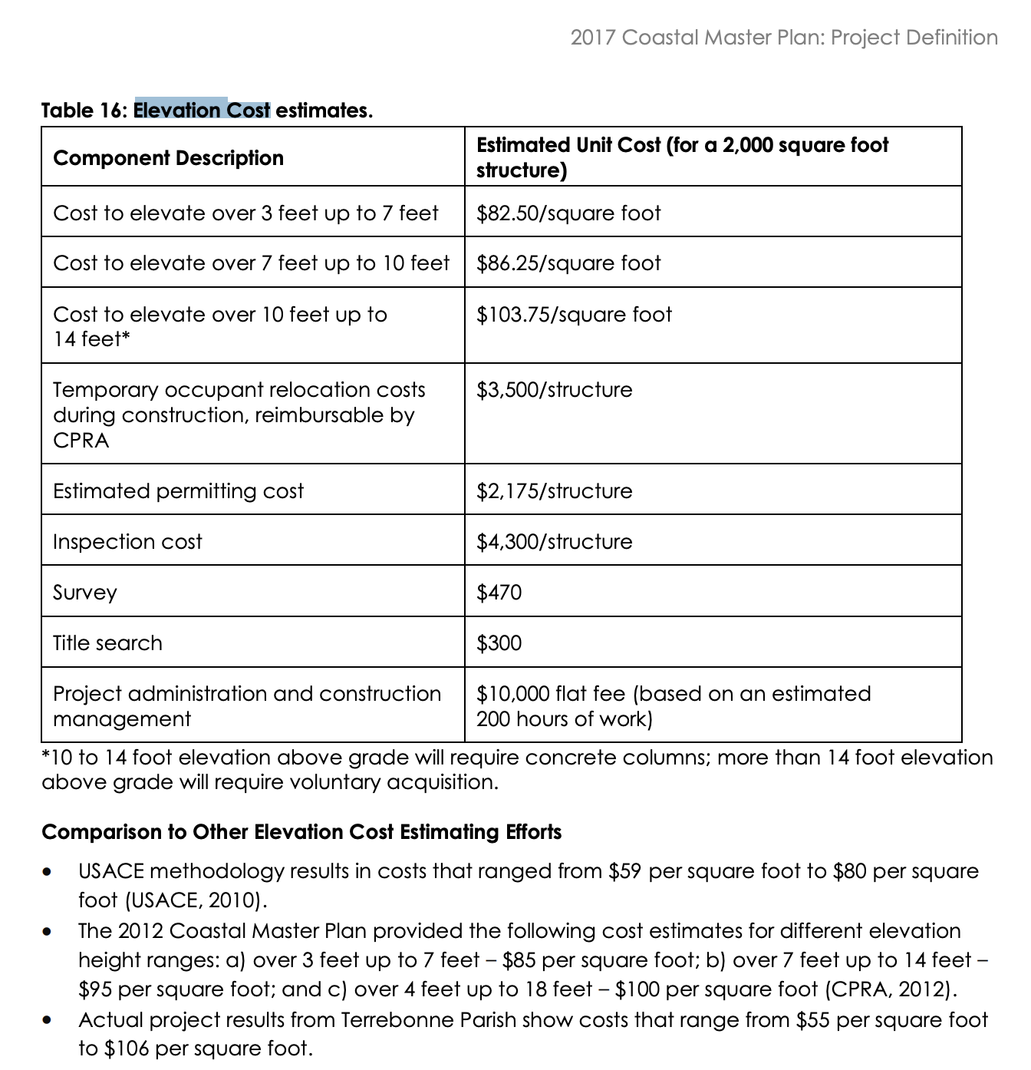

# Methods

# 

## 4.2 Decision criteria

## 1. Safety

Safety is the probability of not being flooded at all uring the lifetime of the house.

## 2. Cost-to-benefit ratio

Cost is the construction fees plus expected damages for each policy.

Benefit is the expected damages elevating the house minus the expected damages before elevating the house.

## 3. total cost as a fraction of house value

This is the fraction of total cost to house value. If this is more than 0.5, house heightening does not make sense

To easily convey this to stakeholders such as homeowners, we created a table as the following:

A definite decision of elevating a house has total of 3 for the second column and a total of 0 in the third column. Similarly, a definite decision of not elevating a house has a total of 0 in the second column and a total of 3 in the third column. The stakeholder can also assign weights to each measure. For example, if the stakeholder cares more about the safety of a house, they can multiply rows by arbitrary weights of 0.5,0.25,0.25.

For safety, a policy gets 1 if its safety is more than 50%.

|  |  |  |  |
| --- | --- | --- | --- |
|  | Not elevating | Elevating to FEMA | Elevating to OPT |
| Safety | 0/1 | 0/1 | 0/1 |
| Benefit/cost | 0 | 0/1 | 0/1 |
| Total cost/house value | 0/1 | 0/1 | 0/1 |
| Total score | 1-3 | 0-3 | 0-3 |

|  |  |  |
| --- | --- | --- |
| Raising the house to cost-benefit optimal makes sense absolutely | 0.65% |  |
| Raising the house to FEMA’s recommendation makes sense absolutely | 1.5% |  |
| No raising the house is the cost optimal policy | 61% | Those houses that the cost-benefit optimal policy is 0 |
| Raising the house is not cost effective |  |  |
| Raising the house would not benefit as much as it costs |  |  |
|  |  |  |
|  |  |  |

Highlight results:

* Houses that were somewhere between -2.6 and 0 feet below the BFE did not need to take acton at all. Square footage of these houses were between 100 and 5000 and value of them were between 80,000 and 1,000,000 USD.



1.

## 4.1 Expected damages

Expected damages are calculated based on a depth-damage function acquired from XXX. The depth damage relationships used in this study are shown in table 2.

Table 2: Depth-Damage relationship used in this study. Contents of the house is also considered in the fraction of damages.

|  |  |  |  |  |  |  |  |  |
| --- | --- | --- | --- | --- | --- | --- | --- | --- |
| Depth of water in the house [ft] | 0 | 1.64 | 3.28 | 4.92 | 6.56 | 9.84 | 13.12 | 16.40 |
| Damage as a fraction of the house value | 0.2 | 0.44 | 0.58 | 0.68 | 0.78 | 0.85 | 0.92 | 0.96 |

# Results

## Flood frequency analysis

Estimating the base flood elevation or 100-yr flood level plays an important role in the decision of elevating a house. FEMA

## Analysis of the optimal elevation for three sample houses

We arbitrarily chose three sample houses and analyzed their optimal elevation in this section. The size and value of these houses are 1,500 (ft2) and 350,000 USD, respectively. The lowest level elevation of house I, II, and III are 9, 7, and 4 feet below the base flood elevation. The objective score tables of these houses are shown in tables 1, 2, and 3, respectively. Additionally, cost of elevation, expected damages, total cost as well as safety and benefit to cost ratio are depicted in figures 1, 2, and 3.



Figure 1: Variation of total cost, benefit to cost ratio and safety with respect to house heightening level. The blue dot in the first panel indicates the cost optimal policy. The gray area in the first panel indicates costs that are equal to the house value. Choosing a policy in this zone leads to substantial costs. The gray area in the second panel indicates that benefit to cost ratio is less than one and policies in that area are not cost effective. Similarly, the gray area in the third panel should be avoided as it indicates less than 50% of safety. The dotted and dashed lines represent the 100-yr flood (base flood elevation) and FEMA’s recommendation (base flood elevation plus one foot of freeboard).

Table 1: The objective score table for house sample I: size=1,500 (ft2), Value=350,000 (US$), lowest level elevation is nine feet below the 100-yr flood

|  |  |  |  |
| --- | --- | --- | --- |
|  | Not elevating | Elevating to FEMA | Elevating to OPT |
| Safety | 0 | 1 | 1 |
| Benefit/cost | 0 | 1 | 1 |
| Total cost/house value | 0 | 1 | 1 |
| Total score | 2 | 3 | 3 |



Figure 2: Similar to Figure 1 but for sample house II with size and value of 1,500 (ft2) and 350,000 (US$) whose lowest level is seven feet below the 100-yr flood.

Table 2: The objective score table for house sample II: size=1,500 (ft2), Value=350,000 (US$), lowest level elevation is seven feet below the 100-yr flood

|  |  |  |  |
| --- | --- | --- | --- |
|  | Not elevating | Elevating to FEMA | Elevating to OPT |
| Safety | 0 | 1 | 1 |
| Benefit/cost | 0 | 1 | 1 |
| Total cost/house value | 1 | 1 | 1 |
| Total score | 2 | 3 | 3 |



Figure 3: Similar to Figure 1 but for sample house III with size and value of 1,500 (ft2) and 350,000 (US$) whose lowest level is four feet below the 100-yr flood.

Table 3: The objective score table for house sample III: size=1,500 (ft2), Value=350,000 (US$), lowest level elevation is four feet below the 100-yr flood

|  |  |  |  |
| --- | --- | --- | --- |
|  | Not elevating | Elevating to FEMA | Elevating to OPT |
| Safety | 0 | 1 | 1 |
| Benefit/cost | 0 | 0 | 0 |
| Total cost/house value | 1 | 1 | 1 |
| Total score | 1 | 2 | 2 |



Figure 4: Similar to Figure 1 but for sample house IV with size and value of 1,500 (ft2) and 350,000 (US$) whose lowest level is at the 100-yr flood.

Table 4: The objective score table for house sample IV: size=1,500 (ft2), Value=350,000 (US$), lowest level elevation is at the 100-yr flood

|  |  |  |  |
| --- | --- | --- | --- |
|  | Not elevating | Elevating to FEMA | Elevating to OPT |
| Safety | 1 | 1 | 1 |
| Benefit/cost | 0 | 0 | 0 |
| Total cost/house value | 1 | 1 | 1 |
| Total score | 2 | 2 | 2 |

## Community analysis of the optimal elevation

Given the plausible ranges of house value, house size, and location with respect to the BFE, we created a set of 1,000 hypothetical houses using Latin hypercube sampling and analyzed the optimal elevation for each of them.

First, we separated houses where both models (ignoring and considering uncertainty) agree that the house should be elevated or not. In the following parallel axes plot, each line indicates a house. Houses that are recommended for elevation are displayed with orange and houses that are not recommended for elevating are shown by blue. In general, it can be concluded that a small expensive houses that is far below the BFE should be elevated because raising the house becomes rather cheap and expected damages are expensive since the house itself is expensive. On the other hand, a large cheap house that is close to the BFE, should not be elevated because the costs of elevating such a house is expensive while the expected damages are low.



Figure ?: Each line indicates a hypothetical house. Orange indicates houses that are not recommended for elevating and blue indicates houses that are recommended for elevating. In all of these houses models with uncertainty quantification and ignoring uncertainty agree in the final decision of elevating or not elevating the house.

To showcase ineffectiveness of FEMA recommendation, look at figures below:





|  |  |  |  |
| --- | --- | --- | --- |
|  | Not elevating | Elevating to FEMA | Elevating to OPT |
| Safety | 26.42% | 100% | 63.31% |
| Benefit/cost | 0% | 35.31% | 37.07% |
| Total cost/house value | 61.58% | 53.05% | 79.28% |
| Total score | 1.88 | 1.88 | 2.40 |

## Analysis of the optimal elevation for three sample houses under uncertainty

In cases where the homeowner decides not to participate in the NFIP or purchase private flood insurance. In the majority of such houses, not raising the house is the cost-optimal policy. We calculated the cost-optimal elevation for a local community of 10,000 houses in the vicinity of the USGS gauge in this study and compared the results with FEMA’s one-foot-above-BFE (OFAB) policy. Figure 1 compares the obtained optimal elevation in this study with FEMA’s recommendation. Each dot in this figure represents a house close to the target USGS gage. Houses are assumed to vary in size, value, the departure from the FEMA’s base flood elevation. The optimal policy for all the houses has a lower total cost than the OFAB policy. The optimal raises of these policies are compared in figure 2 where the histogram of the difference in our optimal height and OFAB is compared. It is noted that in the majority of the houses, the optimal raise is less than OFAB. This is mainly because for those houses elevating a house is not cost effective.

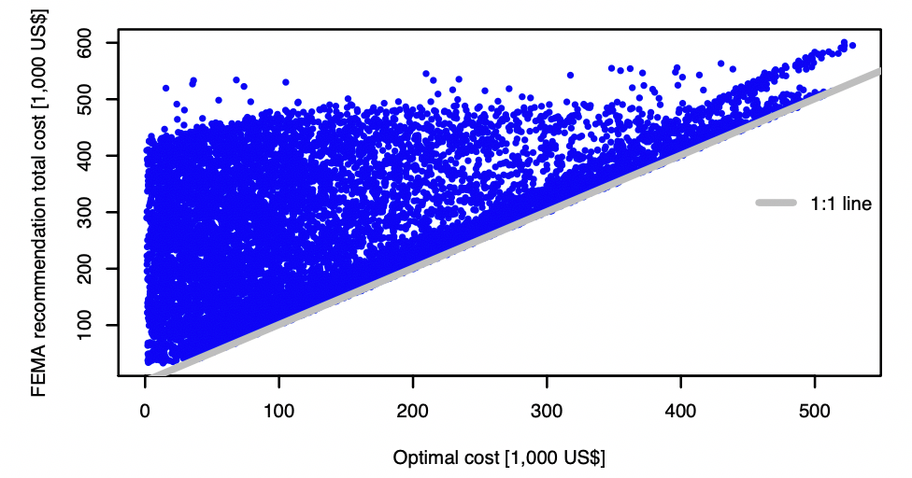

Figure 1: Cost comparison of the cost-effective policy with FEMA’s one-foot-above-BFE policy. Dots represent hypothetical houses in the vicinity of the USGS gage at Sunbury, PA

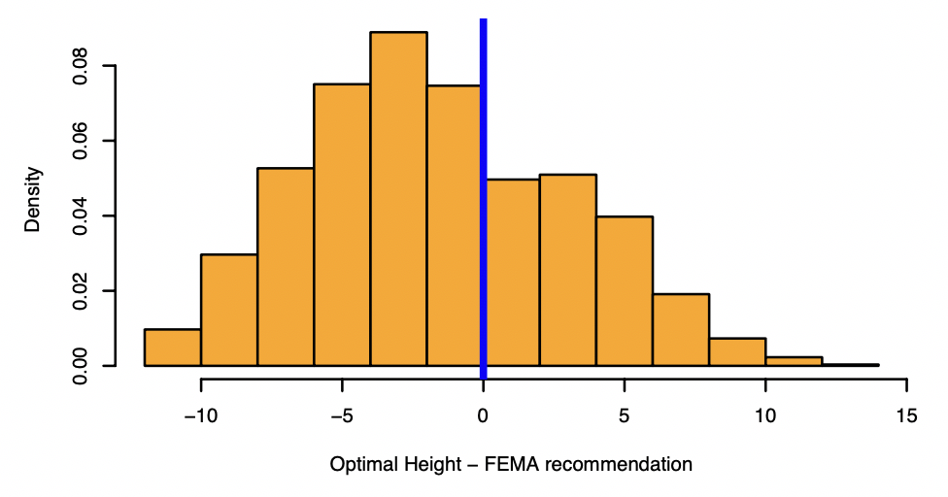

Figure 2: Histogram of the difference the cost-effective policy and FEMA’s one-foot-above-BFE policy. Negative values indicate that OFAB’s policy suggests a higher level of heightening the house and positive values indicate that the cost-optimal policy recommends higher house heightening

Expected damages, construction cost, and total costs are shown in the following. Three houses that are located 9, 6, and 4 feet below the base flood elevation are chosen for demonstration of cost-benefit analysis through figures 3, 4, and 5, respectively. In these figures, the cost-optimal policy is shown by a blue dot and FEMA’s recommendation is shown by a dashed line. For the house that is 9 feet below the base flood elevation, the expected damages are relatively high and therefore, elevating the house is cost-optimal. For this specific house, both approaches suggest the same level of heightening.  The second sample house resides 6 feet below FEMA’s base flood elevation. Similarly, for this house, elevating is recommended; however, the cost-optimal policy suggests raising the house to s higher elevation that FEMA’s OBAF. In this case, the homeowner can invest more money in elevating the house now and save more money by preventing future floods. Finally, for the third house that is located 4 feet below the BFE, elevating is not a cost-optimal policy as expected flood damages are not anticipated to be higher than the cost of elevating. These three houses are good examples to showcase that the elevating a house to one-foot-above-BFE is not always cost optimal. While for certain houses it might be cost-effective, it is not the case for other houses.

and Total costs of three sample houses are shown in figure 3.

Figure 3: expected damages, construction costs, and total cost of various heightening policies ranging from 0 to 14 feet for a house that is located 4 feet below the base flood elevation.

Figure 4: Same as figure 3 but for a house that is located 9 feet below the base flood elevation.

Figure 5: Same as figure 3 but for a house that is located 4 feet below the base flood elevation.

5.2 No flood insurance – Single objective: cost – Considering the uncertainty

Some parameters that are involved in this cost-benefit analysis are uncertain including the extreme value distribution parameters, discount rate, and the house lifespan. Uncertainty of these parameters results in uncertainty of the expected present value of expected damages which could ultimately reverse the decision of elevating a house or not. Figures 6, 7, and 8 show the cost-benefit analysis of the same sample houses when the expected damages are uncertain. While accounting for uncertainties in the first and third house does not make a considerable change in the optimal policy, it entirely reverses the decision if the house should be elevated or not in the second house. For this house, that is 6 feet below the BFE, elevating the house is not recommended if a more scientifically sound method is used to calculate the expected damages. This highlights the significance of considering uncertainties in flood adaptation policymaking since uncertainties could make a considerable change in the chosen policy.

Figure 6: Uncertain expected damages, current cost of construction, and total costs of various elevating policies for a house that is 9 feet below FEMA’s base flood elevation.

Figure 7: Similar to figure 6 but for a house that is 6 feet below the base flood elevation.

Figure 8: Similar to figure 6 but for a house that is 4 feet below the base flood elevation.

Figure 3: XLRM diagram

Figure 4: The added value of uncertainty

Figure 5: Parallel Axes

Figure 6: Sobol sensitivity analysis results

Figure 7: Robustness

# Discussion

<Implications of the results and caveats will be discussed here>

# Conclusion

<A summary of the work plus itemized conclusions will be presented here>

|  |  |  |  |  |
| --- | --- | --- | --- | --- |
|  | Would you abandon? | | Would you consider demolishing and rebuilding? | |
|  | No way | I might | No way | I might |
| No insurance - certainty - cost objective | Homeowner abandons the house if the |  |  |  |
| No insurance - certainty - cost and reliability objective |  |  |  |  |
| No insurance - uncertainty - cost objective |  |  |  |  |
| No insurance - uncertainty - cost and reliability objectives |  |  |  |  |
| With insurance - certainty - cost objective |  |  |  |  |
| With insurance - certainty - cost and reliability objective |  |  |  |  |
| With insurance - uncertainty - cost objective |  |  |  |  |
| With insurance - uncertainty - cost and reliability objectives |  |  |  |  |

# References

<Bibliography>

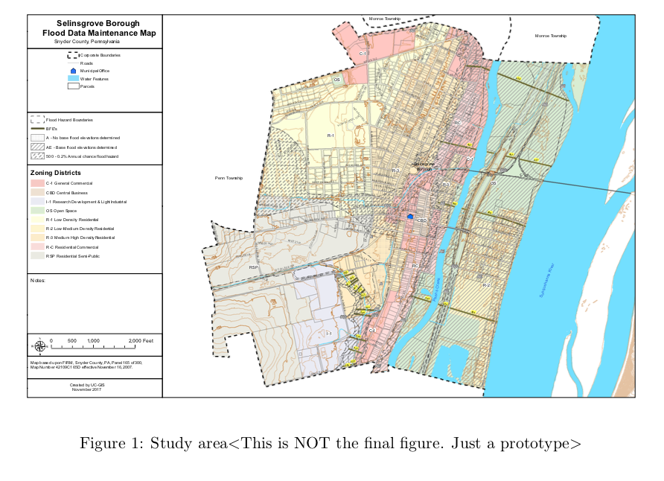

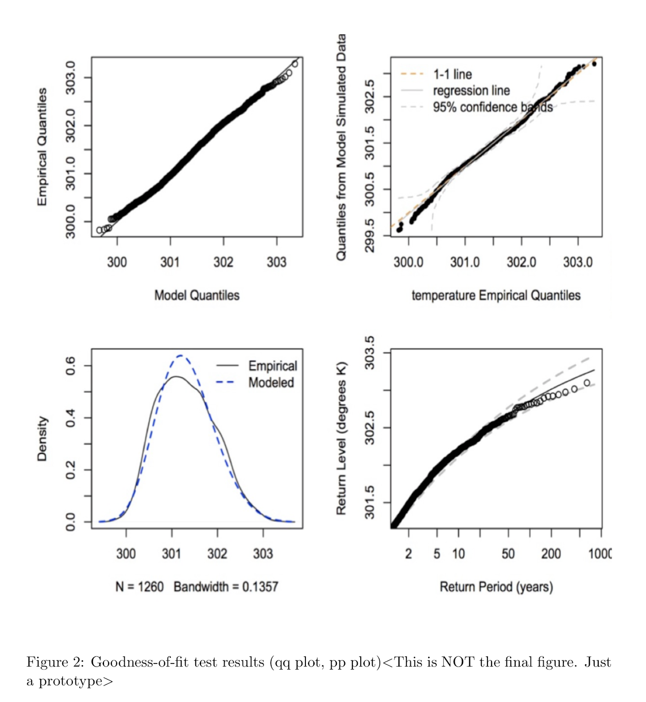

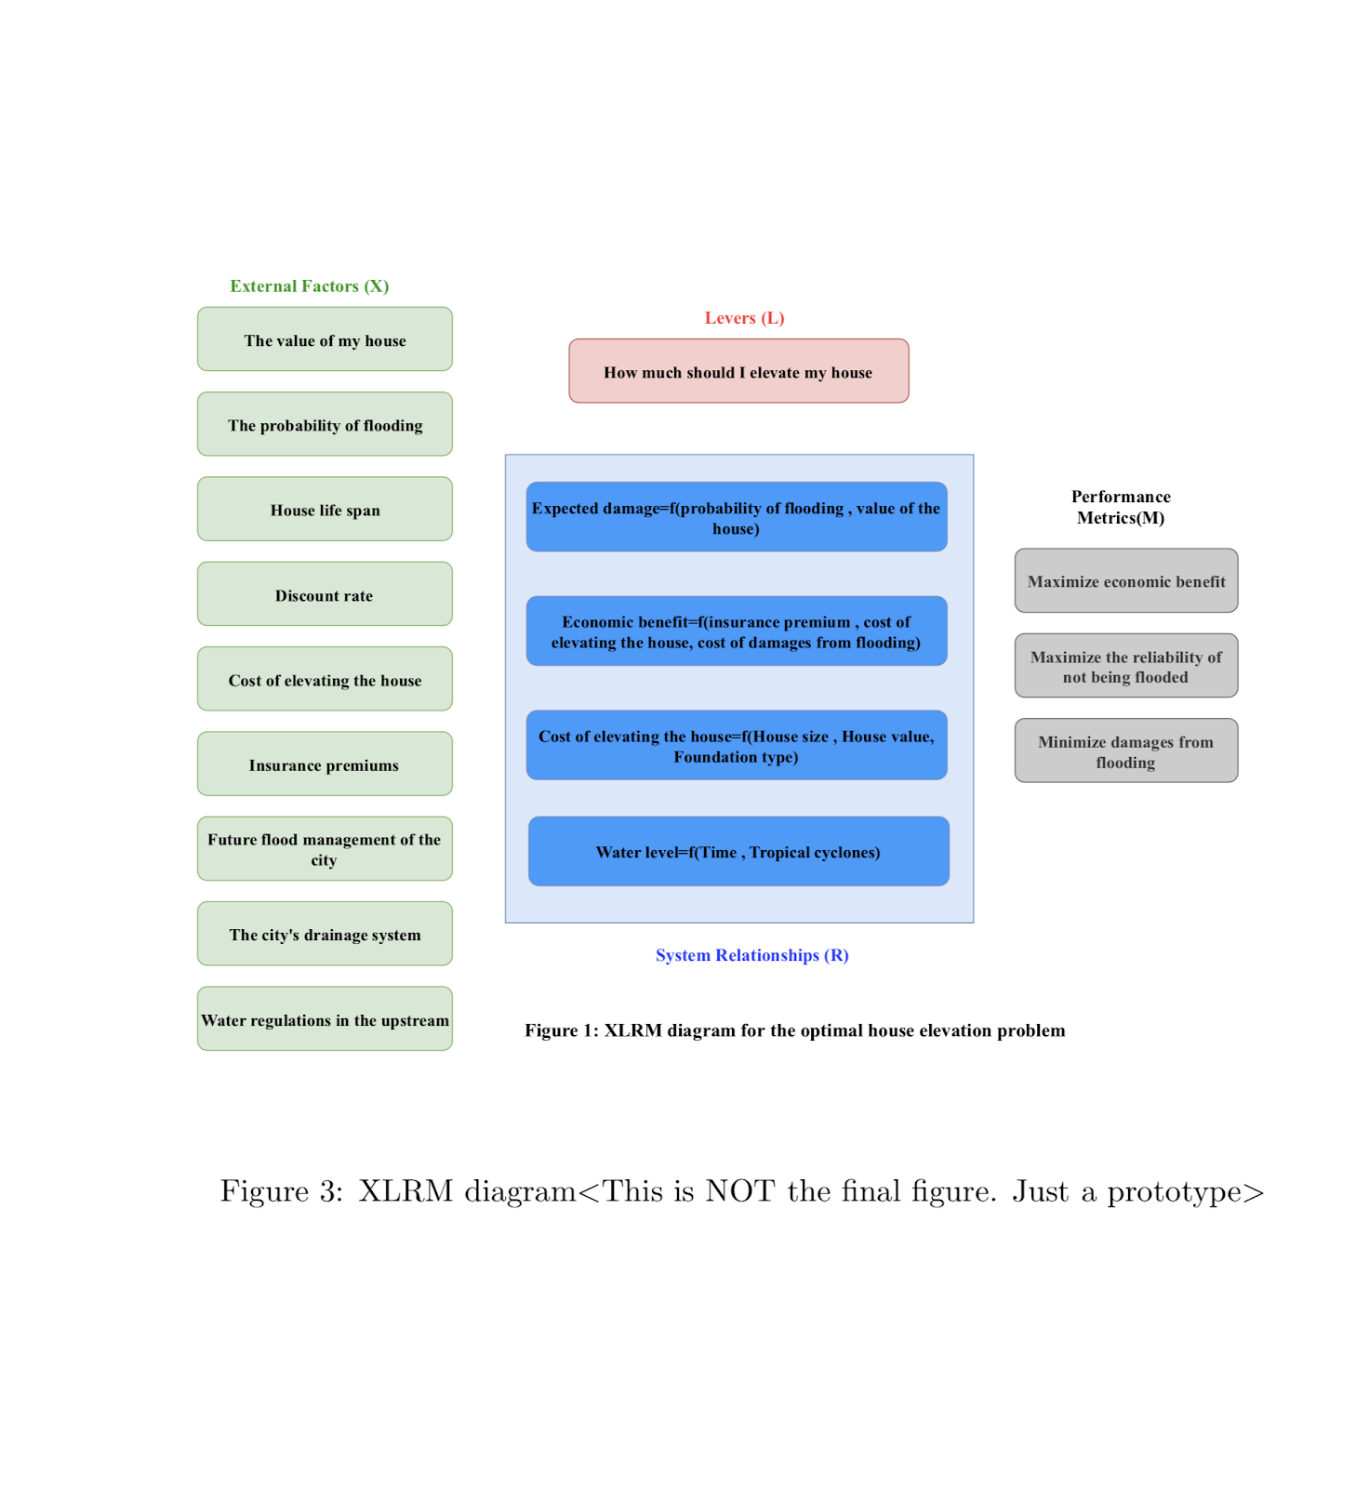

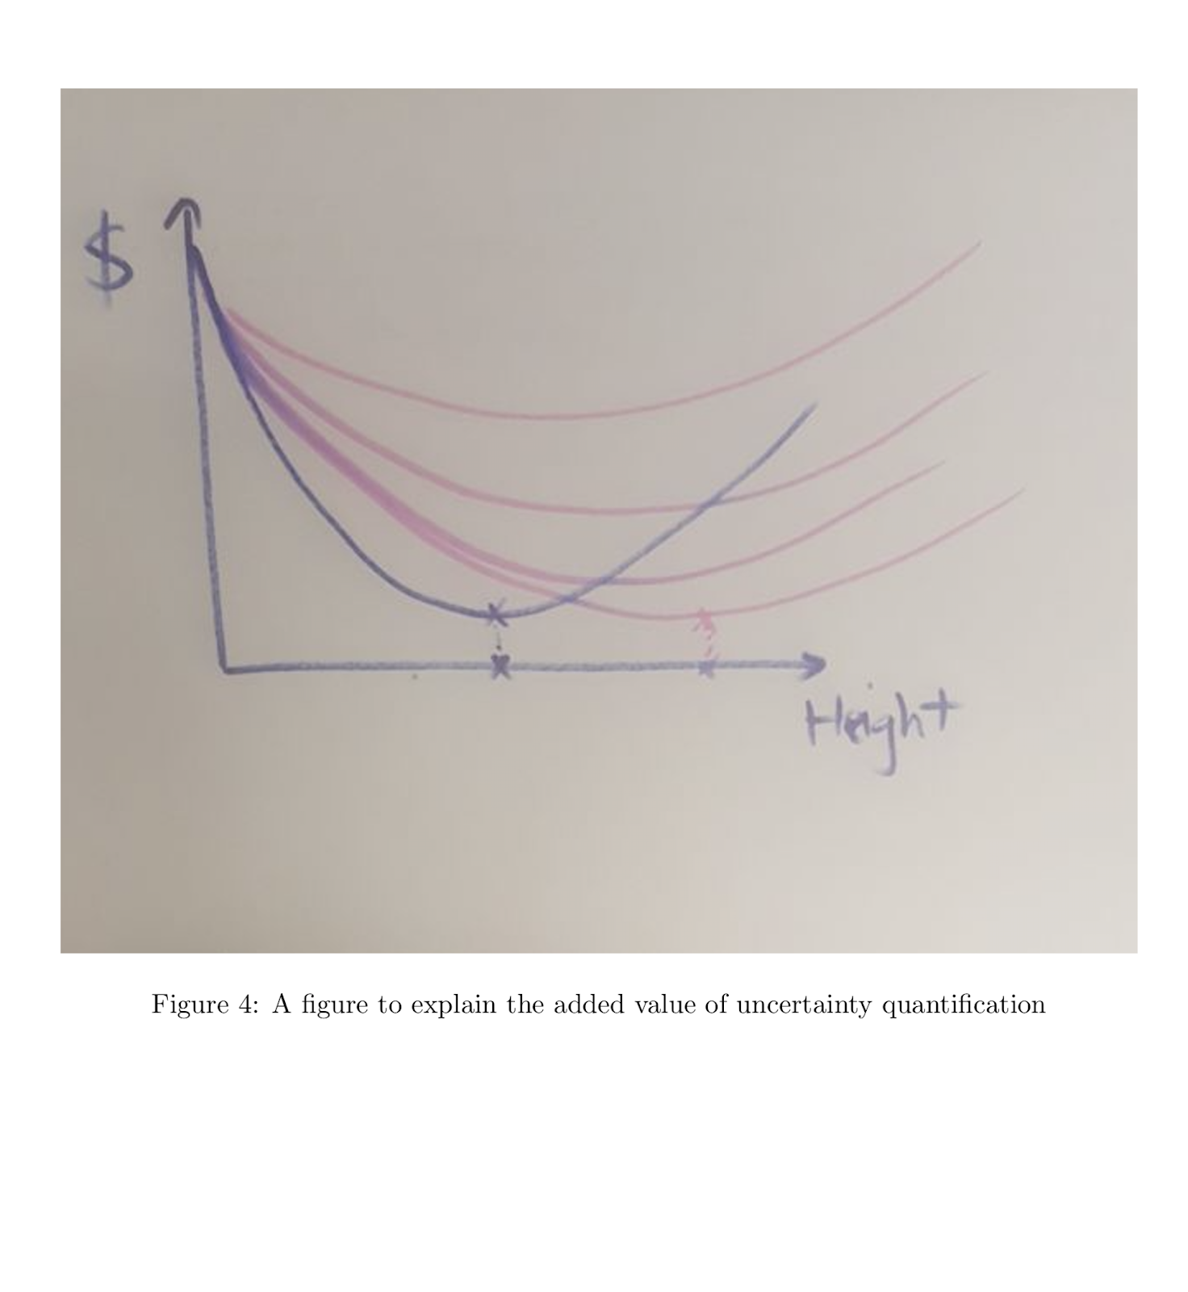

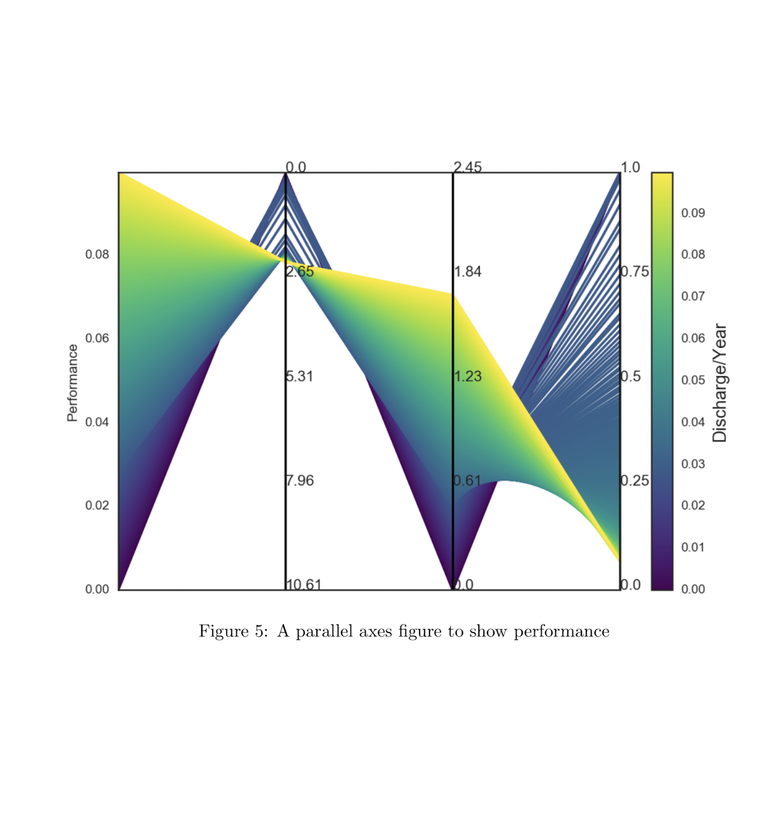

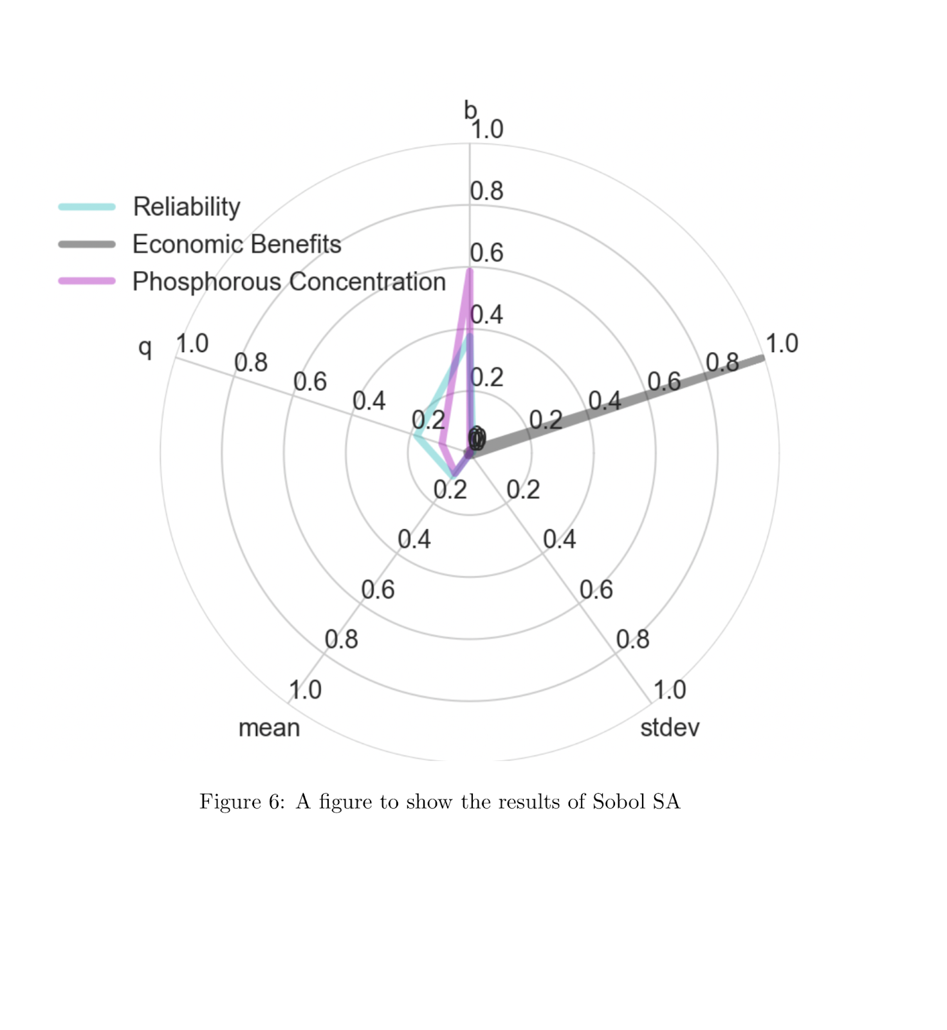

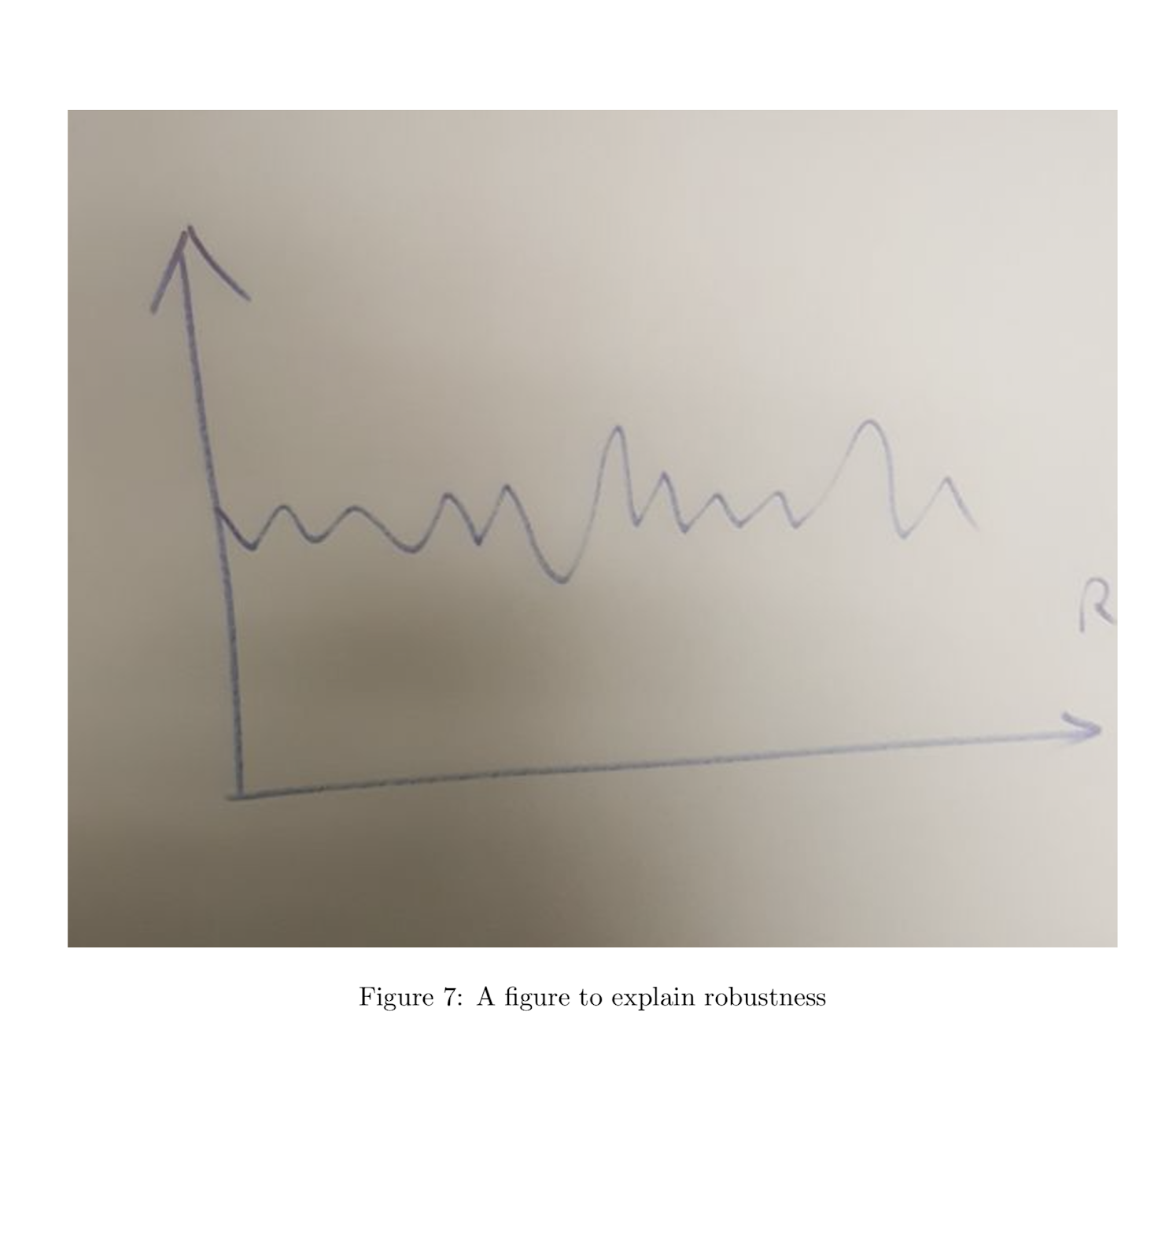

# Supplementary materials

Flood Insurance Rate Map (FIRM)

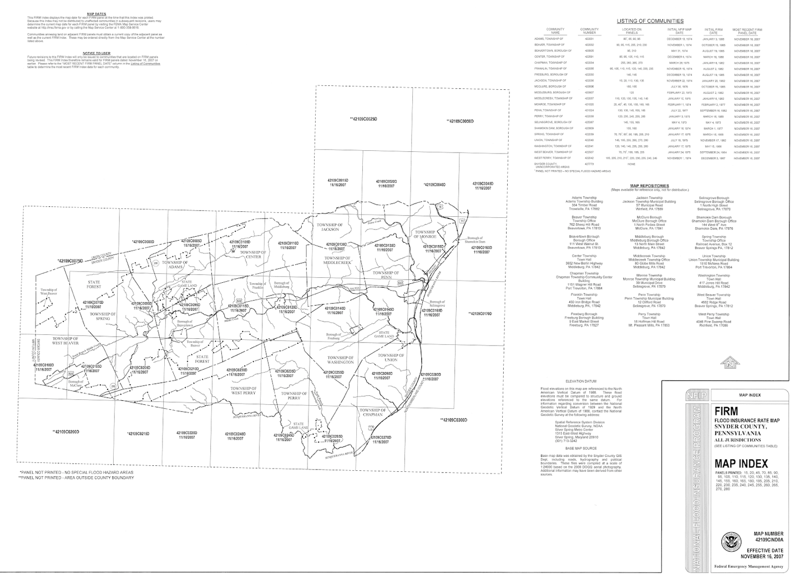

Our gage of interest is located 49102C0155D, Township of Monroe